Addis Ababa Bible Training Institute Report
Student Break Reports - Continued

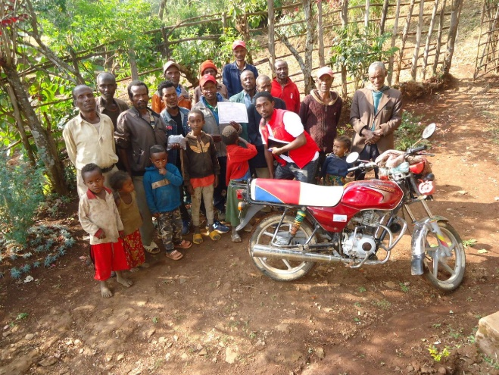

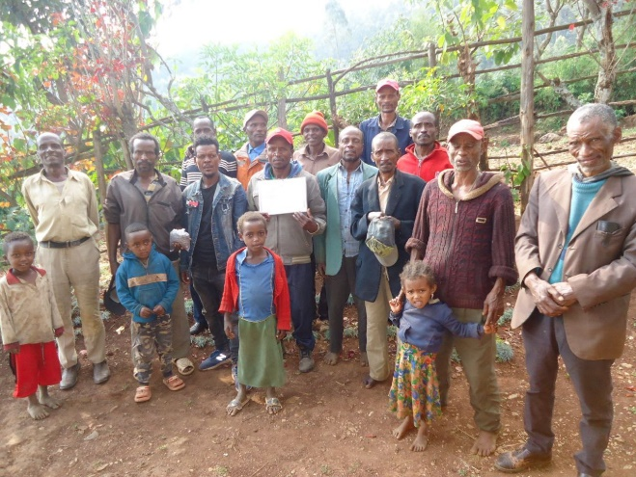

The photographs above were taken on the January school break by another one of our students, Cherenet Desalegn. Cherenet was aware of some struggles in one of the congregations in his home area. Though only 20 years old, he felt compelled to do what he could to help repair the rift that occurred in this church. He knew most of the members well.
The report from Moges, one of our school leaders and translators, was that many advised him that he would not be well received, and he should not go. But Cherenet committed himself to prayer and did indeed go. His initial reception was not a warm welcome. He patiently and humbly expressed his concern for them. He demonstrated this through the provision of grape juice that he purchased with his own money and brought from Addis Ababa.

It took many hours of prayerful discussion, study, and appeals for understanding to set the stage for restored relationships between some of these brethren and between that church and others in the area. Overall, it worked out very well with God’s blessings.

Very often, we are excited to see pictures of individuals being baptized with big smiles and dripping wet clothes. But stories like Cherenet’s do not lend themselves to such visual expressions of healed relationships. You may not see it in the faces and poses of those in the 2 pictures above, but Cherenet’s heart was greatly encouraged by his efforts with this group of Christians in his home area.

I am very proud of Cherenet’s efforts on behalf of a struggling church and the Christians in that church. Cherenet is aware that one visit and voiced intentions to pursue the further healing of broken relationships is no “sure thing.” He has received promises that the parties involved will continue to work to improve relationships with one another and the Lord. Cherenet is a sweet, kind young man. Language issues have made his studies a challenge, but he has put in the effort to improve all through the process thus far. Ease of learning (or not) and grades are not all that’s needed to be a successful servant in the Kingdom.

Pray that each of the 19 men that are continuing their studies with us in Addis will be blessed by the great sacrifices they are making in being away from their families and jobs.

On another note, Deborah (my wife) and I have been blessed to be able to sell our home (closing was February 2nd) and move the limited items we retained from our previous residence of nearly 34 years to a storage shed in Columbia, TN. Our daughter and son-in-law have a separate 800 square foot structure behind their house that we are finishing out to be our “cottage.” This saves us having an empty, unattended house for large amounts of time each year while we are in Ethiopia. But it also provides a sense of “home” (though it will be a while yet) to come home to.

I will be returning to Ethiopia March 22nd until mid-May. Thanks to Joe Boe for spending another 6 weeks teaching in Addis. I am especially grateful to him for tackling “Homiletics” cross-culturally using Alemayehu, Moges, and Behailu to help with that challenging task. Ken Bolden will be arriving in just over a week to spend a month teaching “Sermon on the Mount” and “Biblical Interpretation.”

We have teachers for classes to complete this first year in late August/early September. Next Month I’ll send out the class schedule again and ask that any that are interested in participating with us, look at and commit to some classes for the second year beginning in October.

Many Blessings to each of you,

Jim Wilson

