
Guyana Missions for Christ Ministry
South America, Guyana.
Psalm 82:3: "Whoever is generous to the poor lends to the Lord, and he will repay him for his deed."
Narine Khublall: Missionary @ Guyana’s Mission
E-mail: narinekhublall@yahoo.com
Cell / WhatsApp: 1 (592) 616-1940

SPECIAL REPORT ON THE NEW LALUNI CHURCH BUILDING THAT IS PRESENTLY UNDER CONSTRUCTION

The construction of the new Laluni church building marks a significant milestone for the Guyana Missions for Christ Ministry and the local community in South America, Guyana. This project, spearheaded by missionary Narine Khublall, aims to provide a dedicated space for worship, spiritual growth, and outreach activities. The church will serve as a beacon of hope, offering a place where community members can gather for prayer, fellowship, and support.
Currently, the building is in the active construction phase, with the foundation and structural framework being set up. The project has received generous support from donors and volunteers, inspired by the biblical call to assist those in need as referenced in Psalm 82:3. The ministry is working diligently to ensure that the new church will be both functional and welcoming, equipped to accommodate various programs and events for all age groups.
Progress updates are shared regularly by the ministry, and donations continue to be welcomed to help complete the building. Upon completion, the Laluni church will not only enhance the spiritual life of the community but also provide resources and outreach services to uplift the people of Laluni and its surroundings. For further information or to support the project, interested individuals can contact Narine Khublall via email at narinekhublall@yahoo.com or WhatsApp at 1 (592) 616-1940.
The construction of the new Laluni church building, which started in October of 2024, has faced tremendous obstacles such as the unpredictable weather patterns coupled with heavy rains. In addition, the project has required the persistency of the skilled and semi-skilled labourers, as well as the dedication of non-skilled workers. Other significant challenges include securing and transporting building materials to the worksite and raising finances on a regular scale.
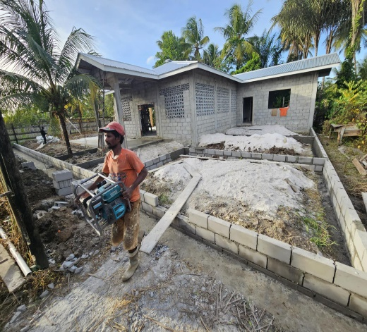
Photo Gallery: Construction of the New Laluni Church Building
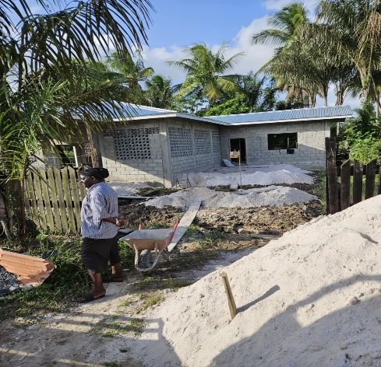
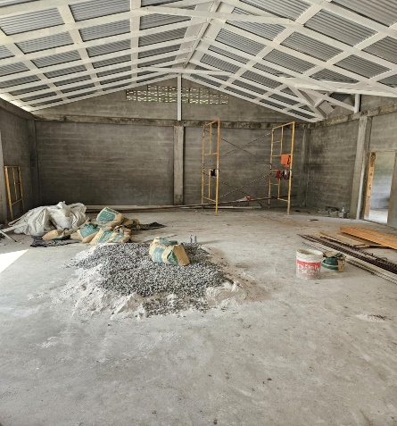
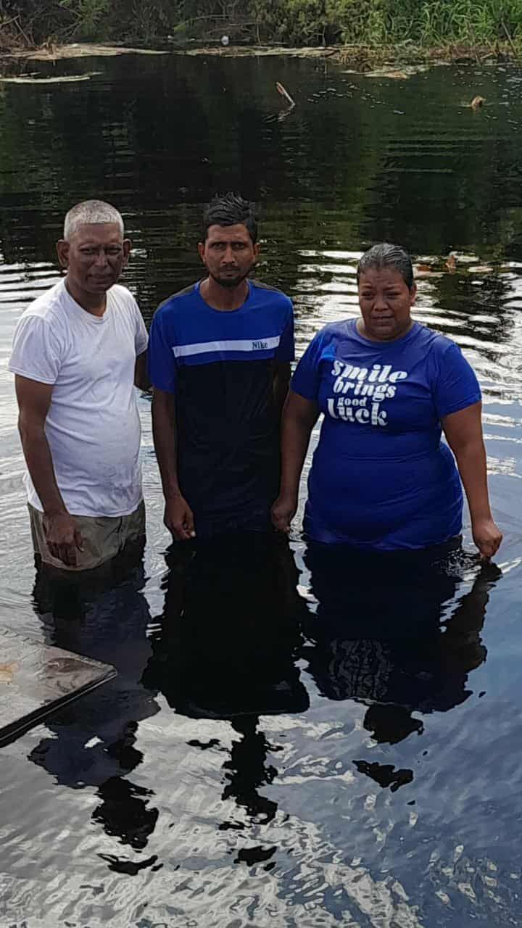

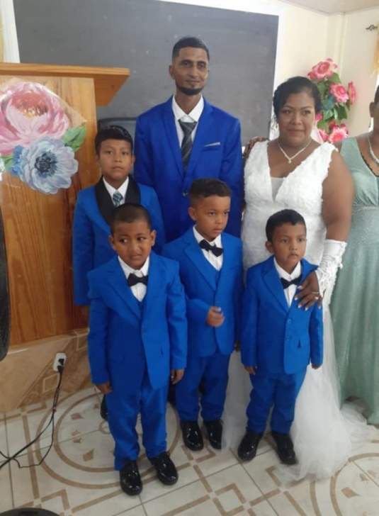
In the picture above this is Mahase and Ruby. They both lived at the Tobacco Plantation, Laluni Creek, Laluni... (where the new Laluni church is presently under construction) they lived home together for seven years without the matrimonial blessings. Saturday, June 28,2025 they both were married at the Kuru Kururu Church of Christ. They both have four boys.
They attend the Kuru Kururu Church of Christ every Sunday ever since. May God’s abundant blessings be upon Mahase and Ruby as they embark on this new chapter of their lives together. May their marriage be filled with love, understanding, and enduring faith, and may they continue to be a source of inspiration and support for their family and community. May the Lord guide and protect them always, strengthening their bond with each passing day.
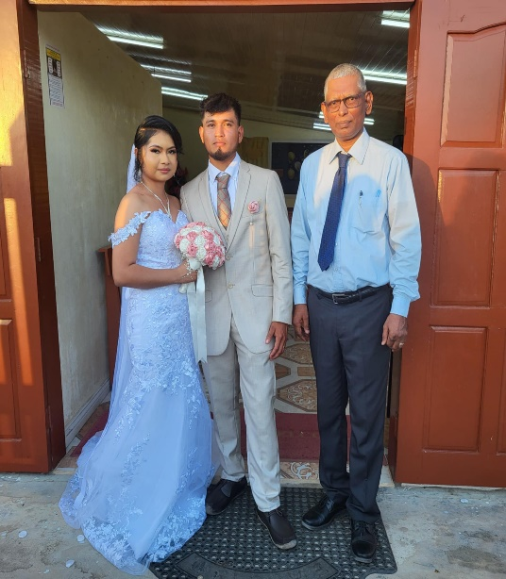
A wonderful couple Ryan Dundas & Jennifer Dabideen entered into a matrimonial relationship on Saturday, January 10, 2026, at the Kuru Kururu Church of Christ. They are from the Tobacco Plantation of Laluni Creek, Laluni, known each other for (6) six years. It was a great blessing to see lots of folks from the Laluni community attending the wedding ceremony. God's richest blessings upon this young couple. May God's grace abundantly blesses Ryan Dundas and Jennifer Dabideen as they begin their journey together as husband and wife. May their home be filled with love, mutual respect, and unwavering faith, and may their union inspire others in the Laluni community to walk in harmony and hope. May the Lord guide their steps, grant them wisdom in every situation, and shower them with joy, good health, and prosperity as they build their life together.
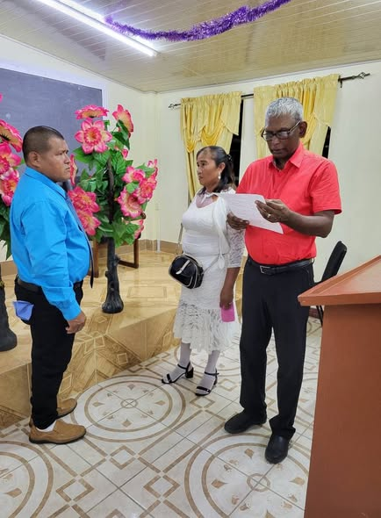
On the 31st day of December 2024, this wonderful couple Filden Lawrence Dundas and Rose Adina Jacobs have decided to end (25) twenty-five years of living together unmarried and in a "Common Law" relationship.
This couple has 6 children and lives in Laluni Creek, Laluni and I always encouraged them to seek God's way.
This is the first marriage that has been done there since the Kuru Kururu Church of Christ started to evangelize this community.
The church will soon be officially launched in this community.
May God’s blessings rest richly upon Filden and Jacobs as they begin this new journey together in holy matrimony.
May their love be steadfast and enduring, and may their faith guide them through every season of life. May the Lord grant them wisdom, unity, and joy, and may their home be a place of peace, kindness, and unwavering support for one another and their children.
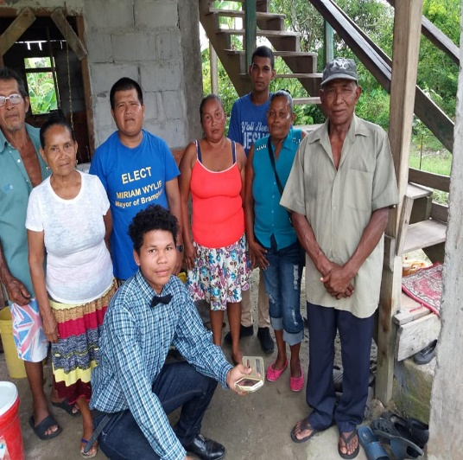
The Laluni community is home to several devoted Christian families who exemplify faith and unity in their daily lives. One such is the Dundas’s family as is shown in the picture.
Although, their livelihood is physically poor but their commitment to love and serve God is seen in their daily lives.
This family supports the construction of the new Laluni church building by supporting security in the night stands as a testament to their enduring faith.
Their journey, marked by love, perseverance, and spiritual growth, continues to inspire many within the Laluni community and beyond.

The support for the Guyana Mission work has been truly heartening and impactful. The
The construction of the new Laluni Church building has provided employment to many persons, offering much-needed opportunities for work and growth within the community. This initiative not only strengthens the local community but also unites residents in a shared purpose, fostering a sense of pride and togetherness.
Their acts of service—ranging from providing security at the church construction site to offering encouragement and hospitality—reflect a spirit of unity and faith that strengthens the mission’s foundation.
As the mission continues to expand, such support plays a vital role in fostering spiritual growth, building community relationships, and inspiring others to get involved. The collective efforts of the community ensure that the message of hope and salvation reaches many, and the ongoing commitment of supporters will undoubtedly bless generations to come.
God’s richest blessings upon those who have financially assisted the mission and church building efforts. May their generosity be rewarded abundantly, and may their contributions continue to make a lasting impact within the Laluni community and beyond. Their support stands as a testament to compassion and faith, uplifting all who benefit from their kindness.

